**Normalization :-**

Normalization is the process of organizing data in a database to minimize redundancy and improve data integrity. This involves dividing large tables into smaller, more manageable tables and defining relationships between them. The main goals are to eliminate duplicate data, ensure data dependencies make sense, and reduce the chances of data anomalies. Here are the key steps of normalization:

1. **First Normal Form (1NF)**: Ensure that each table cell contains a single value and each record is unique.
2. **Second Normal Form (2NF)**: Ensure that the table is in 1NF and all non-key columns are fully dependent on the primary key.
3. **Third Normal Form (3NF)**: Ensure that the table is in 2NF and all the columns are dependent only on the primary key.
4. **Boyce-Codd Normal Form (BCNF)**: A stricter version of 3NF where every determinant is a candidate key.

**Denormalization**

Denormalization is the process of combining normalized tables to improve query performance by reducing the number of joins required. This can introduce redundancy into the database, but it can also significantly speed up read operations, especially in systems where read performance is more critical than write performance. Here are some common denormalization techniques:

1. **Adding Redundant Data**: Intentionally introducing duplicate data to reduce the number of joins.
2. **Pre-Joining Tables**: Combining tables that are frequently joined to reduce the complexity of queries.
3. **Creating Summary Tables**: Storing precomputed summaries of data to speed up reporting and analysis.

**Normalization :-**

Normalization is process of designing the database effectively such that we can remove the redundancy (duplicate data).

**1NF**

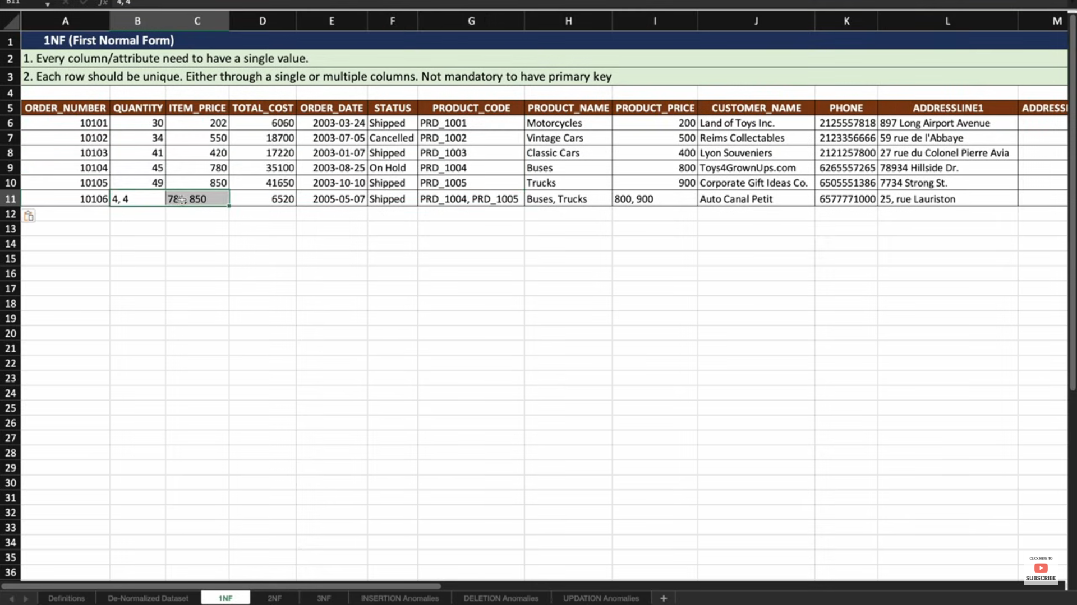

**Step 1**: Every column need to have single value.

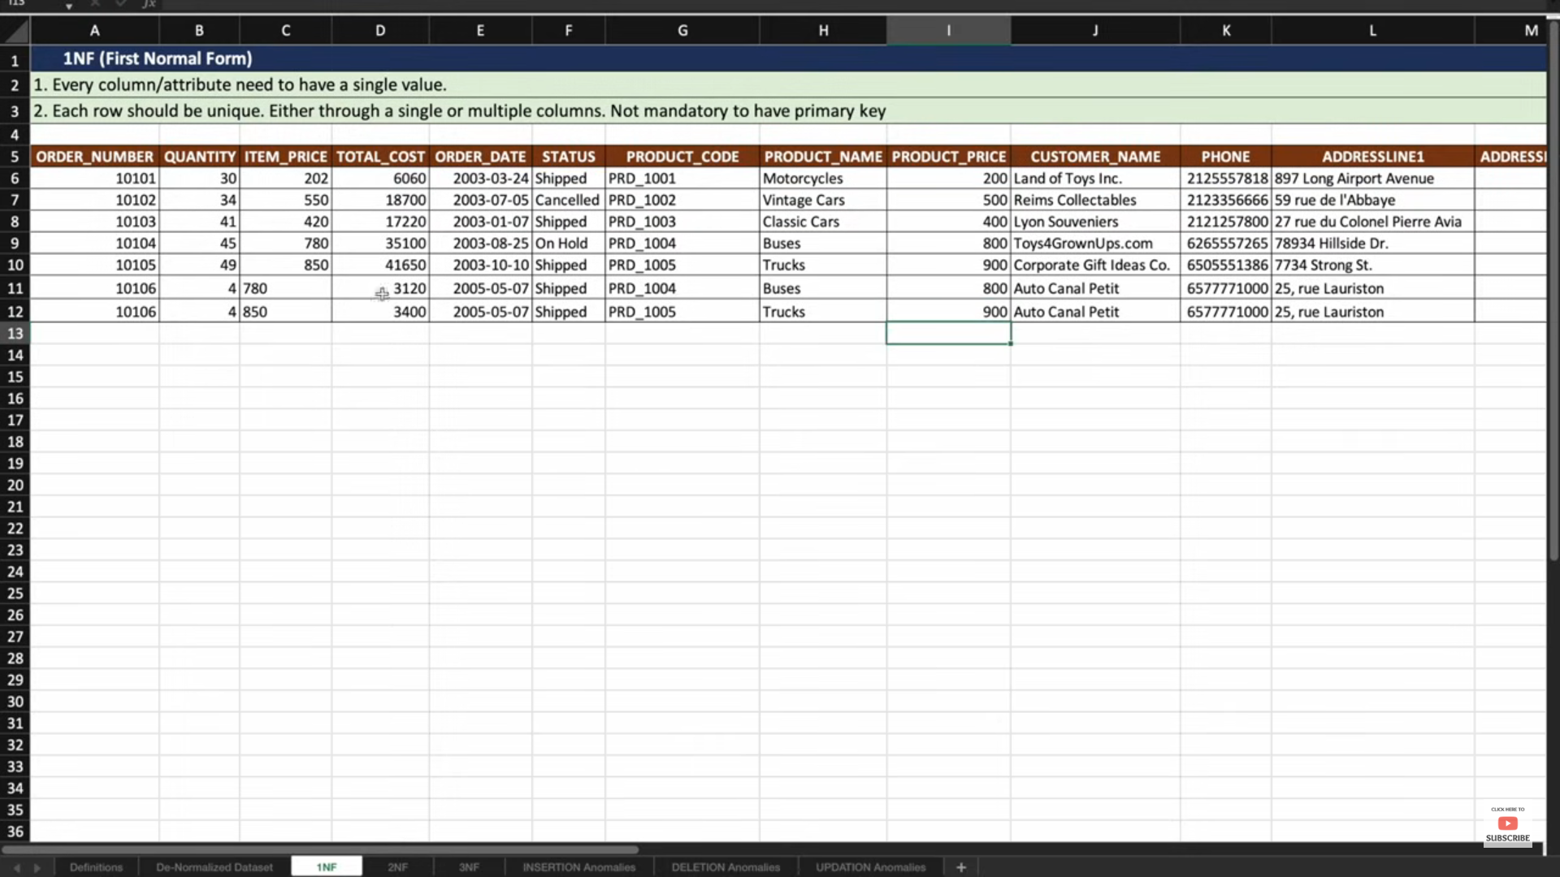

**Step 2**: Each row should be unique. Either through single or multiple columns. Not Mandatory to have primary key.

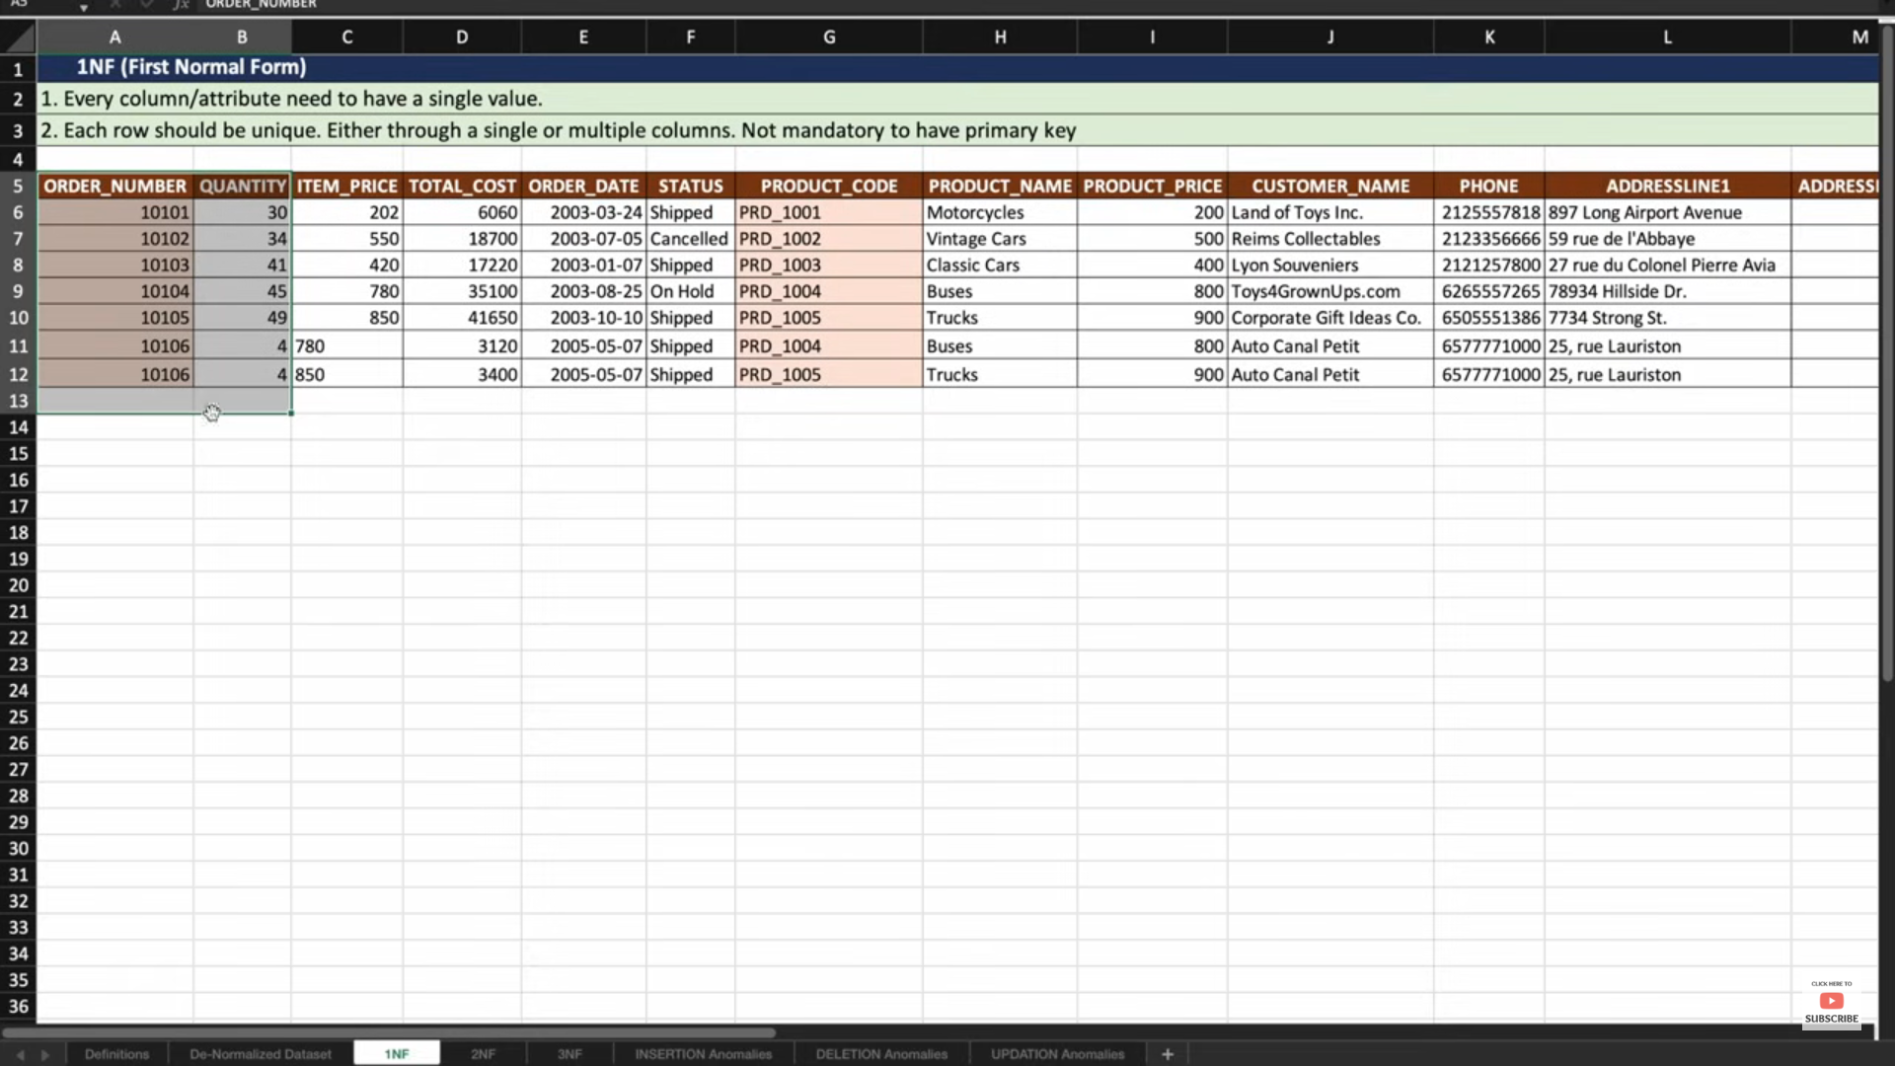

**2NF**

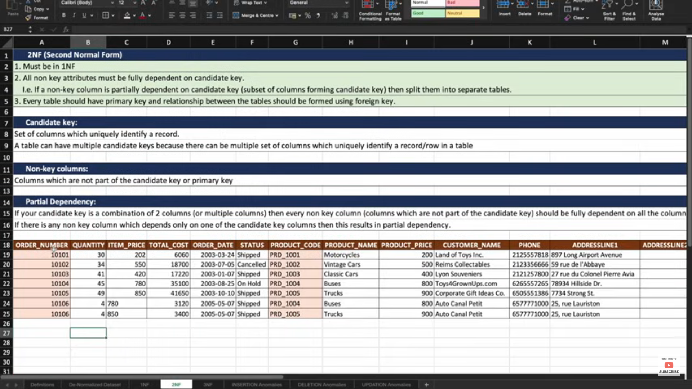

**Step 1:** Must be in 1NF

**Step 2**: All non-key columns must be fully dependent on candidate key i.e, if a non-key column is partially dependent on candidate key(subset of columns forming in a candidate key)then split them into separate tables

**Candidate Key:** Set of columns which is uniquely identify a record. A table can have multiple candidate key because there can be multiple set of columns which is uniquely identify a record/row in a table.

Note: In the above example Order_Number||Product_name -> uniquely identify a recordso we call it is Candidate key

**Non-Key Columns**: Columns which are not part of the candidate key or primary key.

**Partial Dependency:**  if a candidate key is combination of two columns (or multiple set of columns) then every non-key column (which are not part of the candidate key and primary key) fully dependent on all columns in candidate key.

If there is any non-key column which depends only on the one candidate key columns then this results in partial dependency.

**Candidate Key**-> Order_Number||Product_name(In the above Example).

**Note :**

Quantity, Item_price ,total_cost ,order_date ,status columns ->only dependent on Order_Number column **so these are partial dependency(why because we have candidate key combination of Order_number||Prodcut_code))**

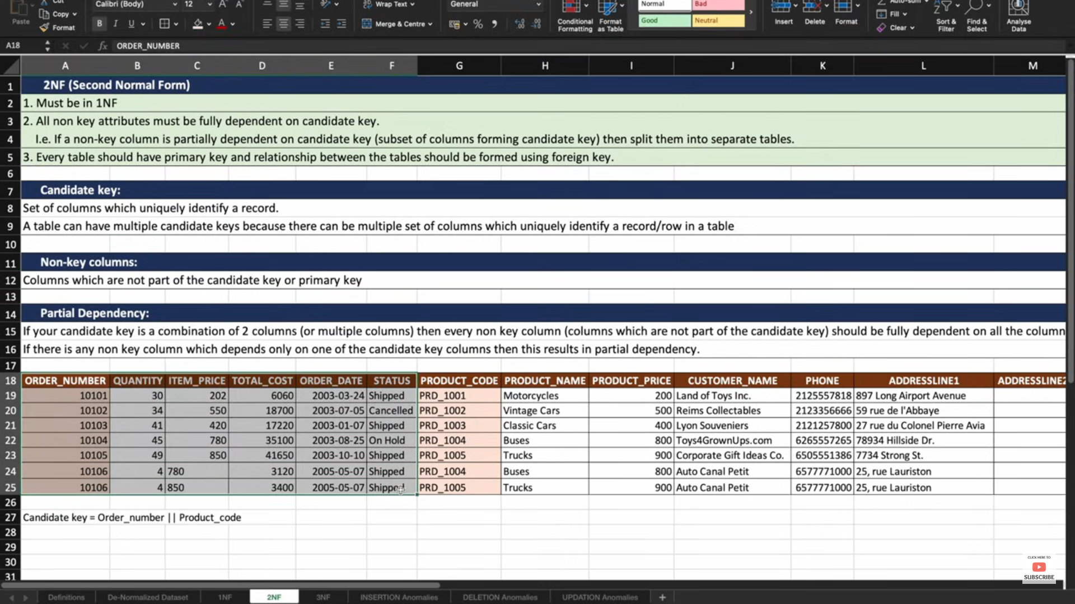

Product_Name,Product_Price->only dependent on Product_code column. **so these are partial dependency(why because we have candidate key combination of Order_number||Product_code))**

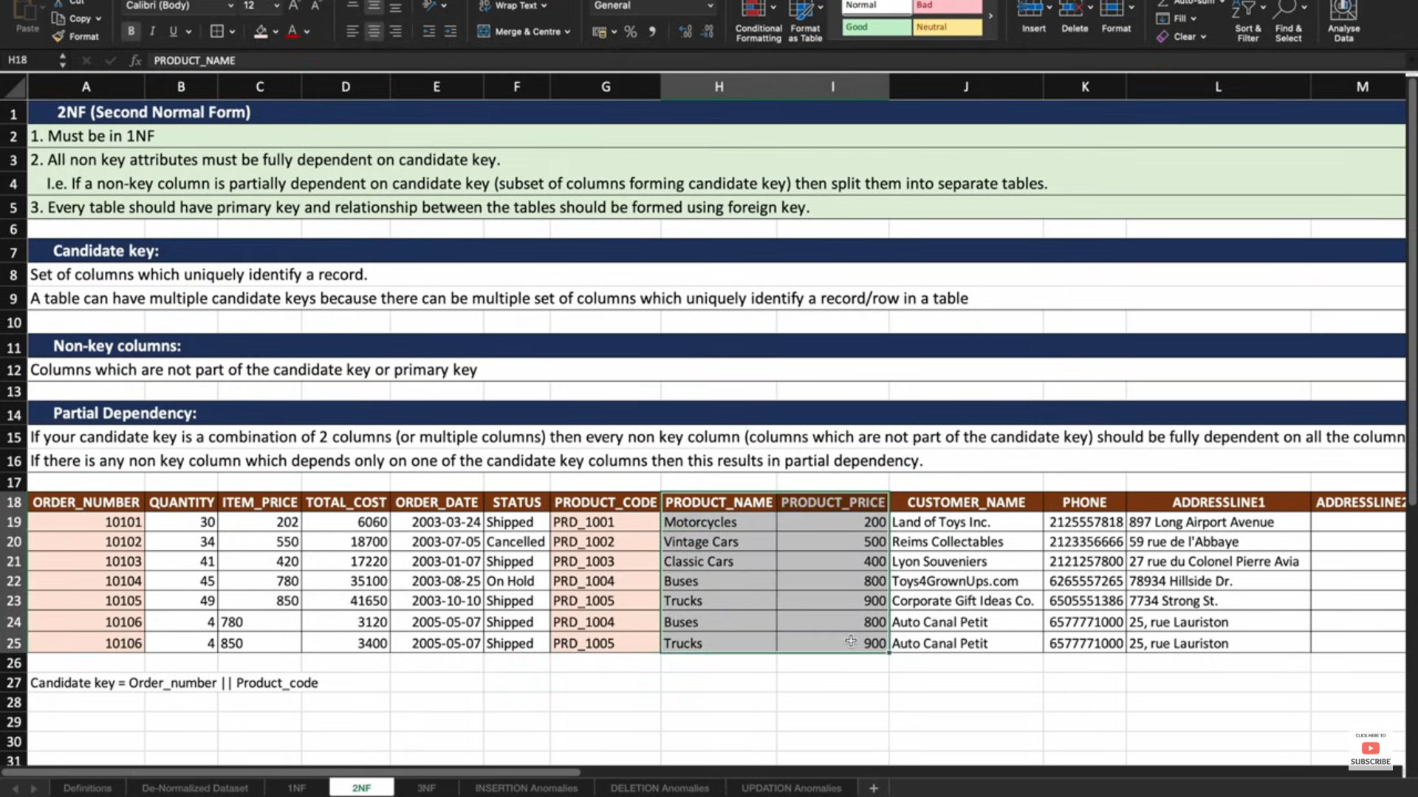

Phone_number,Address_Line1,Address_Line2->only dependent on Customer_Name Column

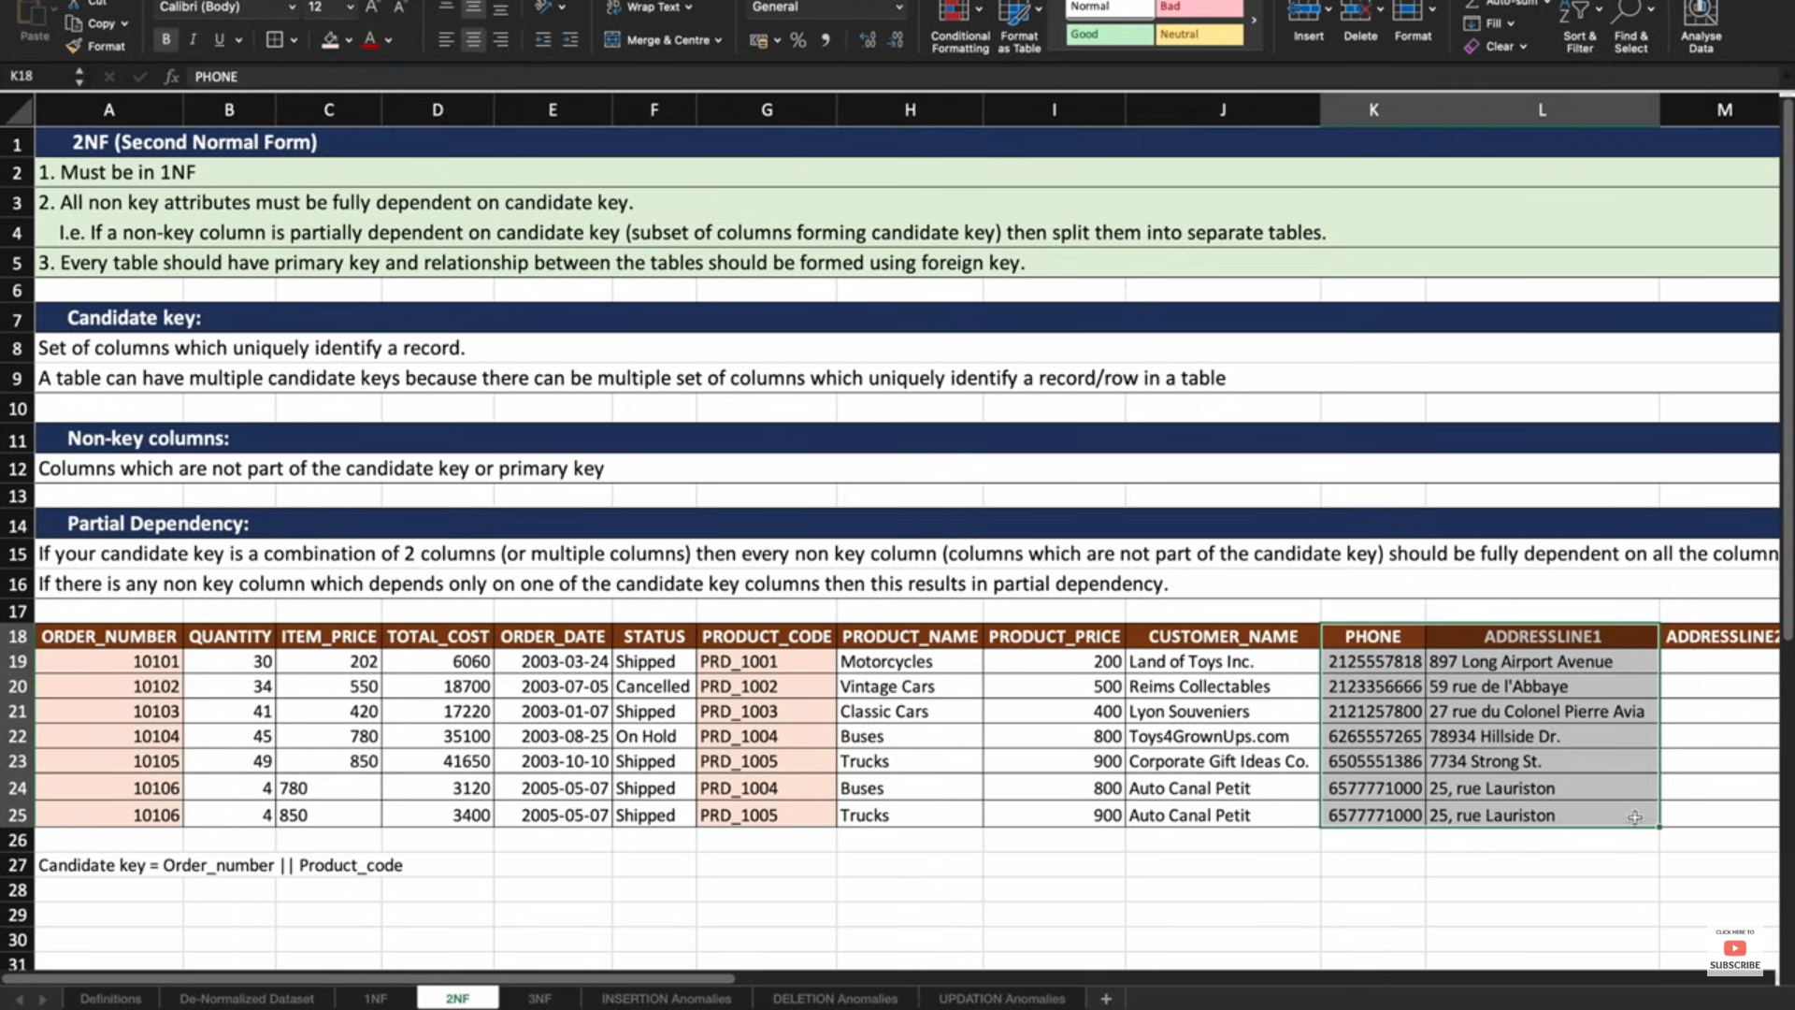

So to avoid Partial dependency we need to create separate tables for that columns.

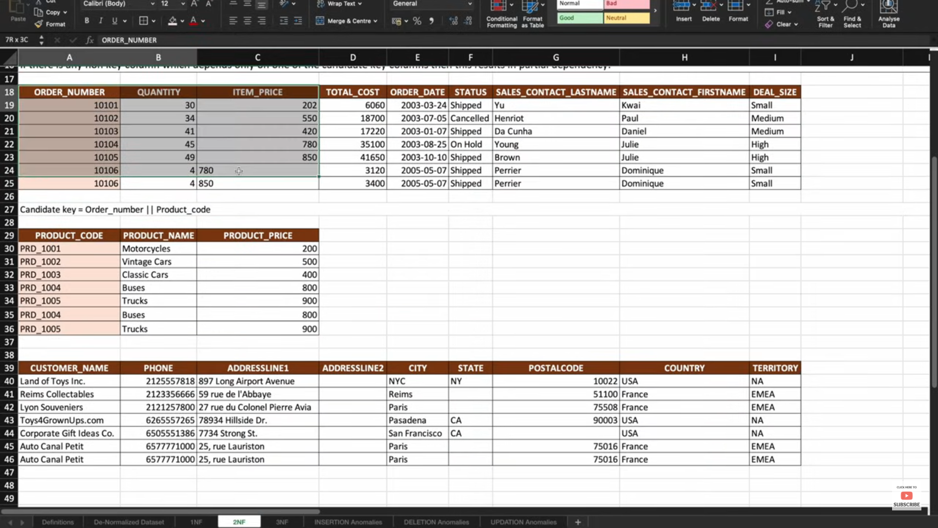

**Step 3**: Every table should be Primary key and foreign key and establish the relationship between those tables using foreign key.

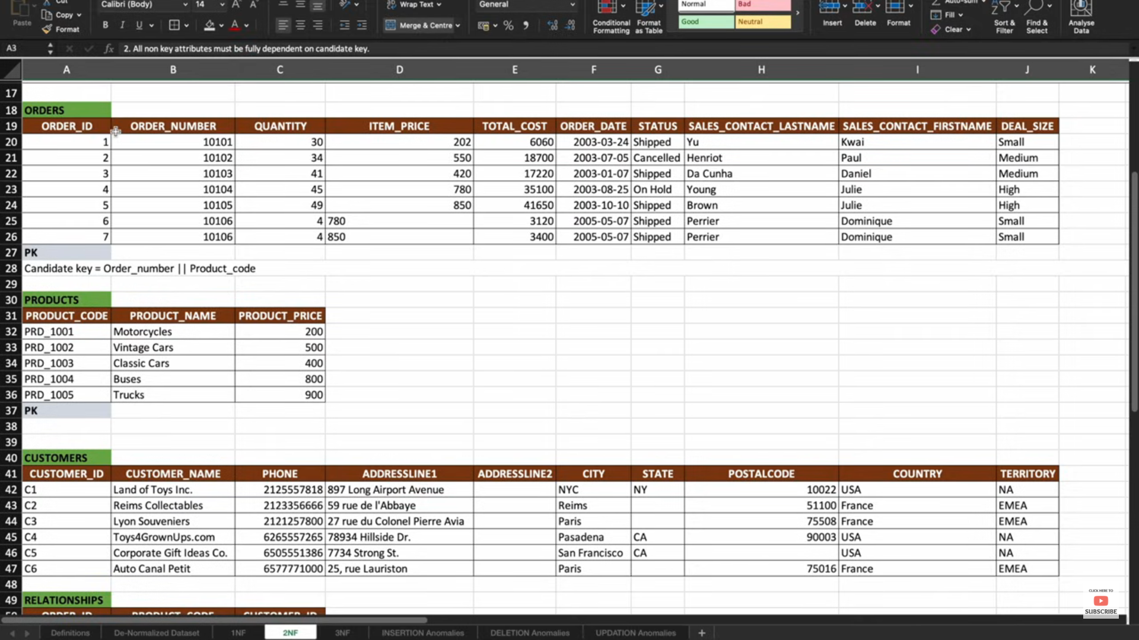

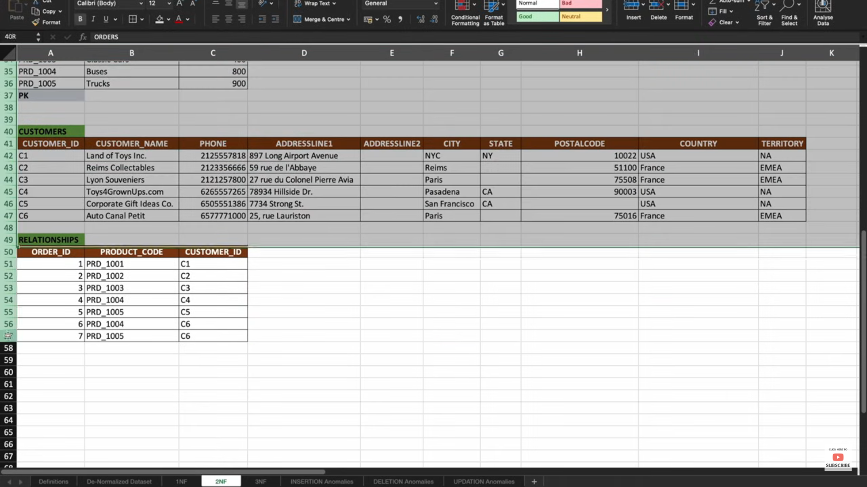

**3NF**

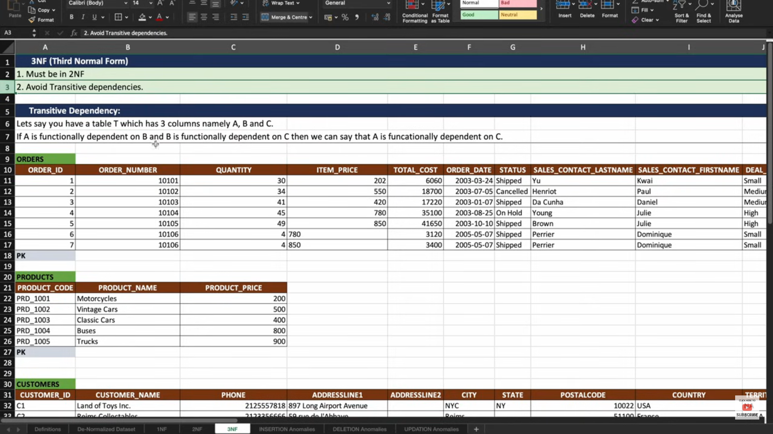

**Step 1:** Must be 2NF

**Step 2:** Avoid Transitive Dependencies

**Step 3**: There is no Derived attributes on the table(Suppose we have salary column and Annual Salary column. We derived annual salary

Column from Salary column(Sal*12=Annual Sal) those type columns we need to avoid to store in table.

**Transitive Dependency :**

1)Consider we have 3 columns in a table i.e, A,B and C

2)if A functionally dependent on B and B functionally dependent on C then we can say A A functionally dependent on C**.**

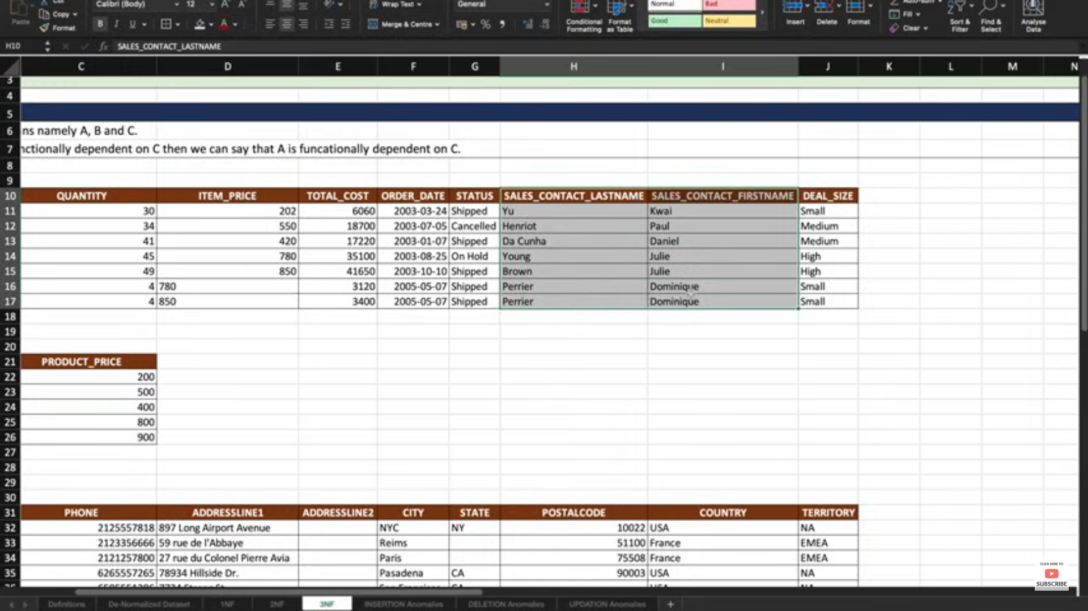

In the above example Sales related information functionally dependent on Orders table.so to avoid transitive dependency we need create separate table for Sales data**.**

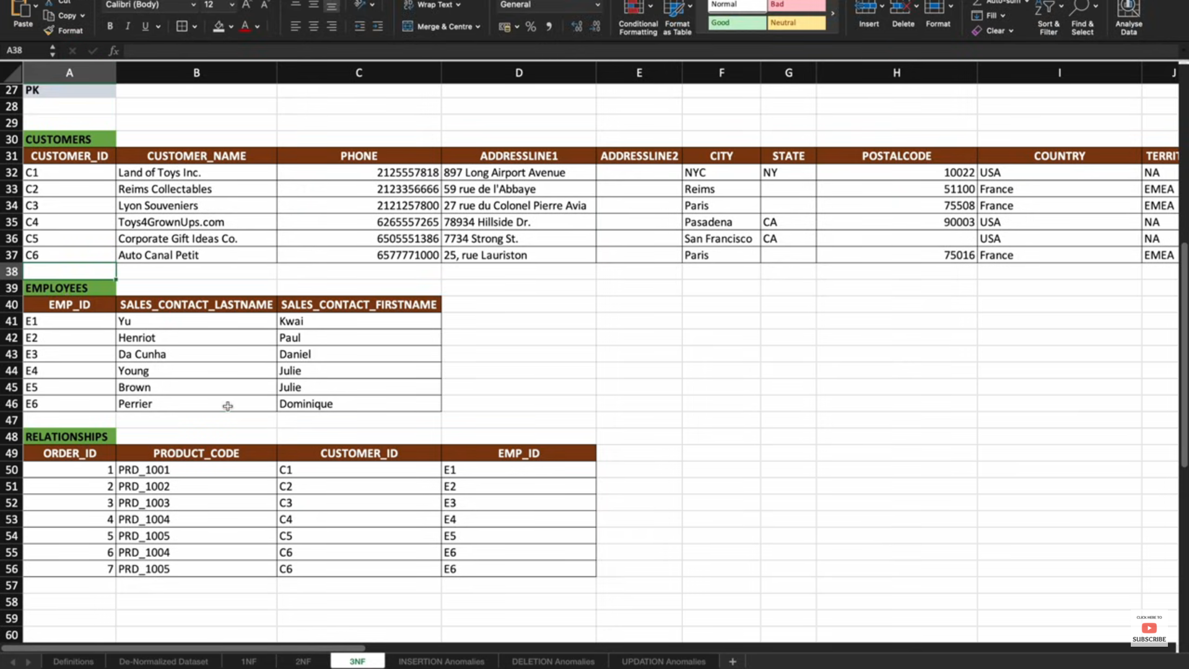

Then Finally Orders table,products table,customer table and employee table below

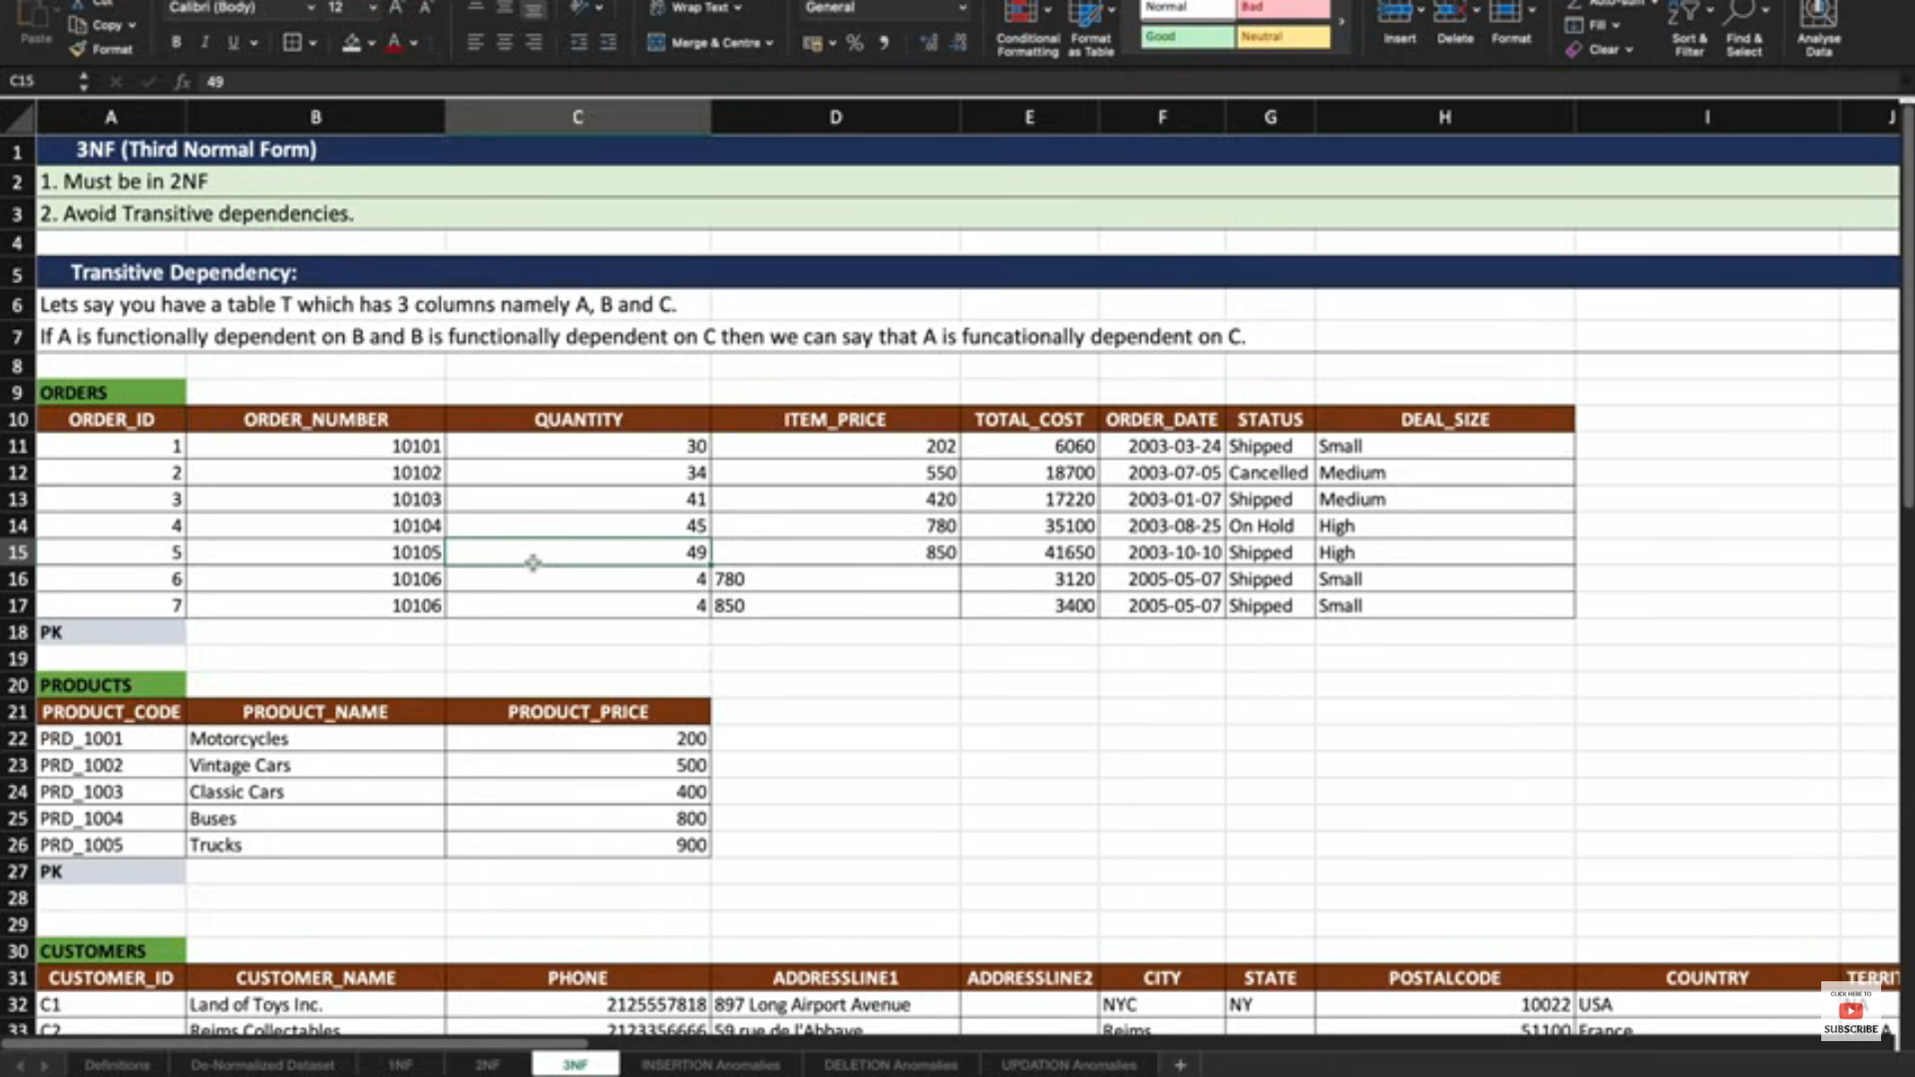

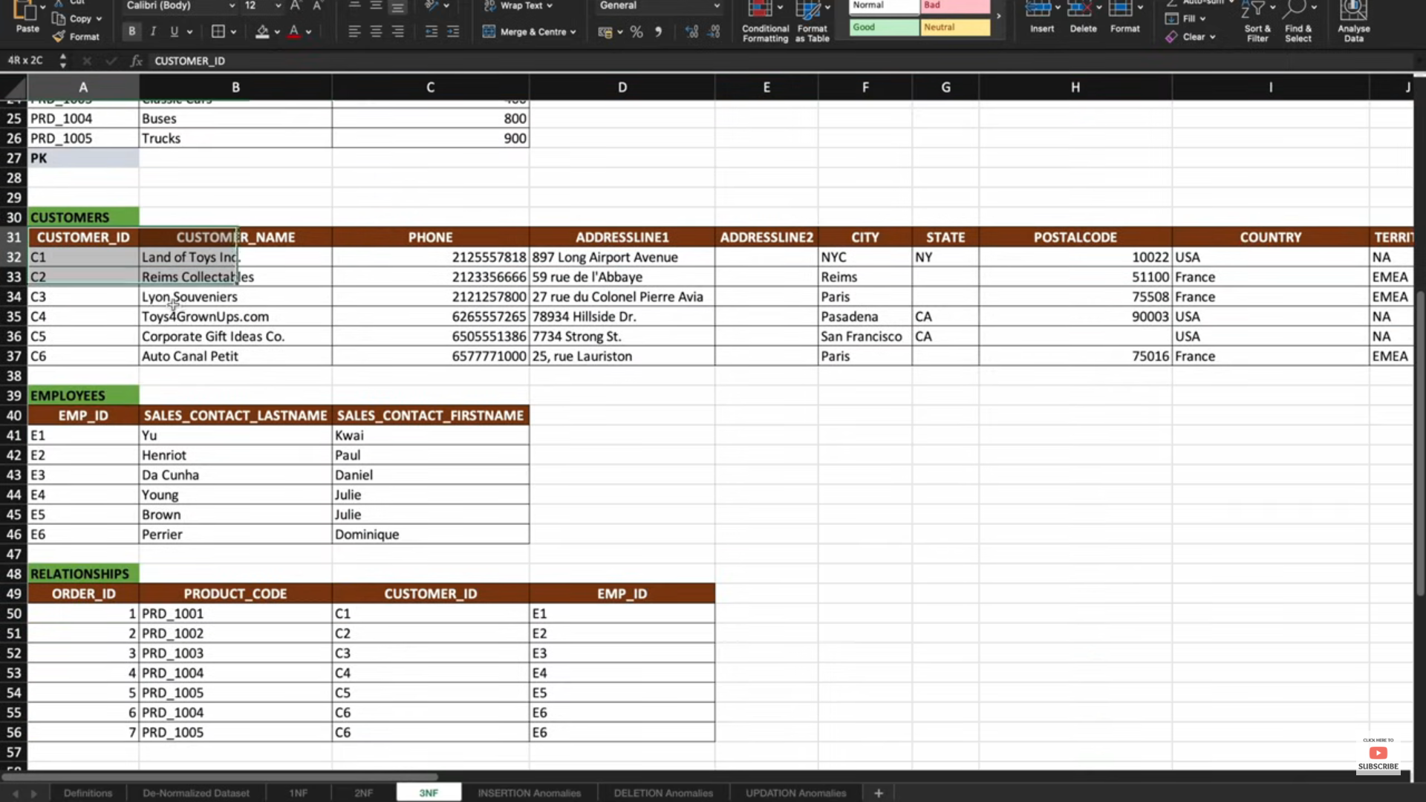

**Insertion Anomiles**

If we want to insert product info in table for denormlized table some data missing in table i.e, order info and customers info

**Denormlized table**

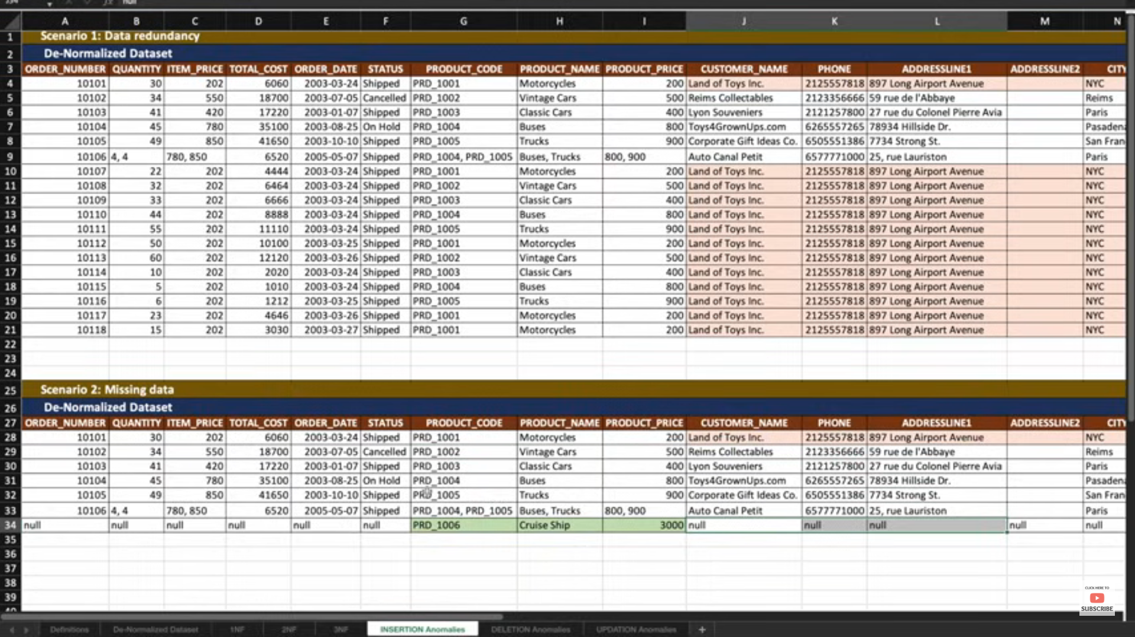

**Normalized Table**

**If table is normalized we can easily insert data in product table we do not required any other info about orders,customers table**

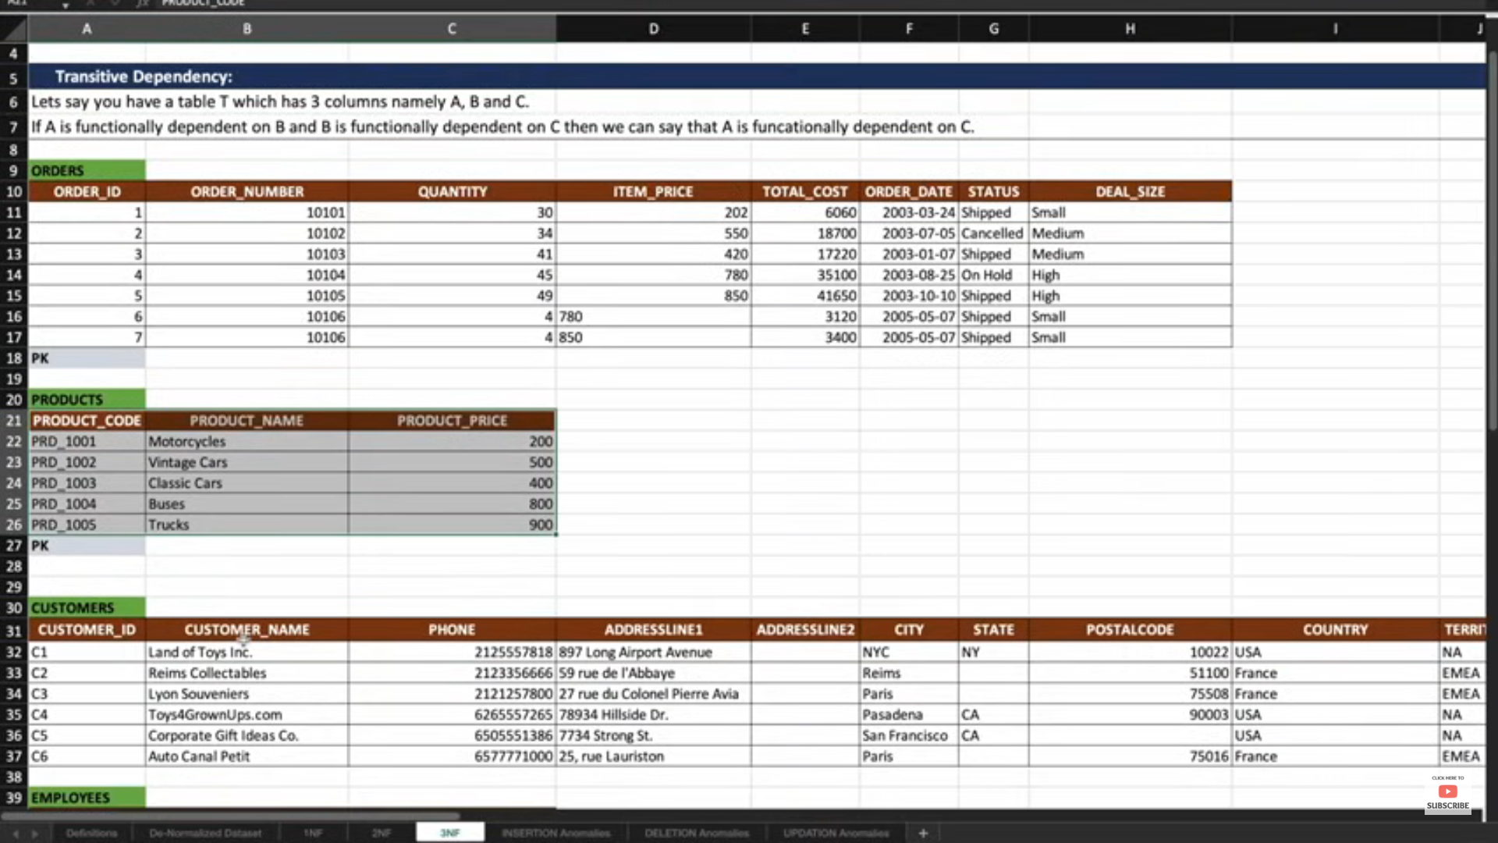

**Deletion Anomalies :If we want to delete one order information in table**

**Denormalized Table:-we are loosing the products and customers table data info**

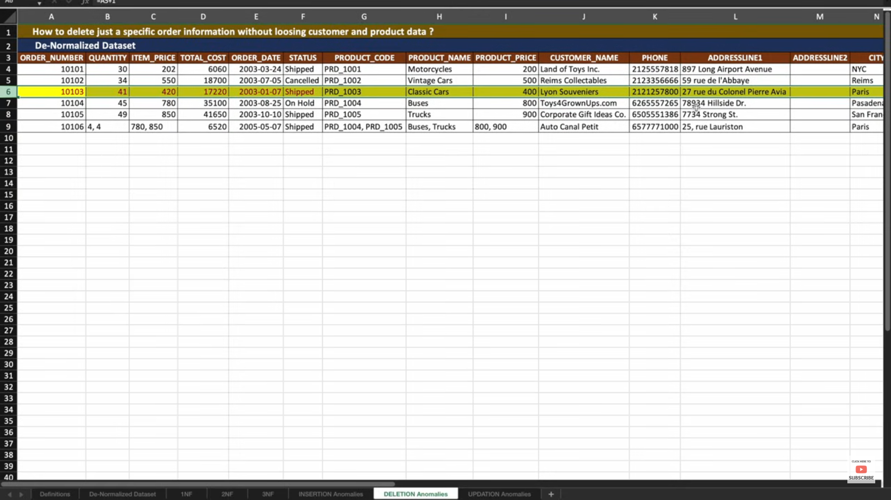

**Normalized Table :now we can easily delete data in orders table so we are not loosing any data for products and other related table info.**

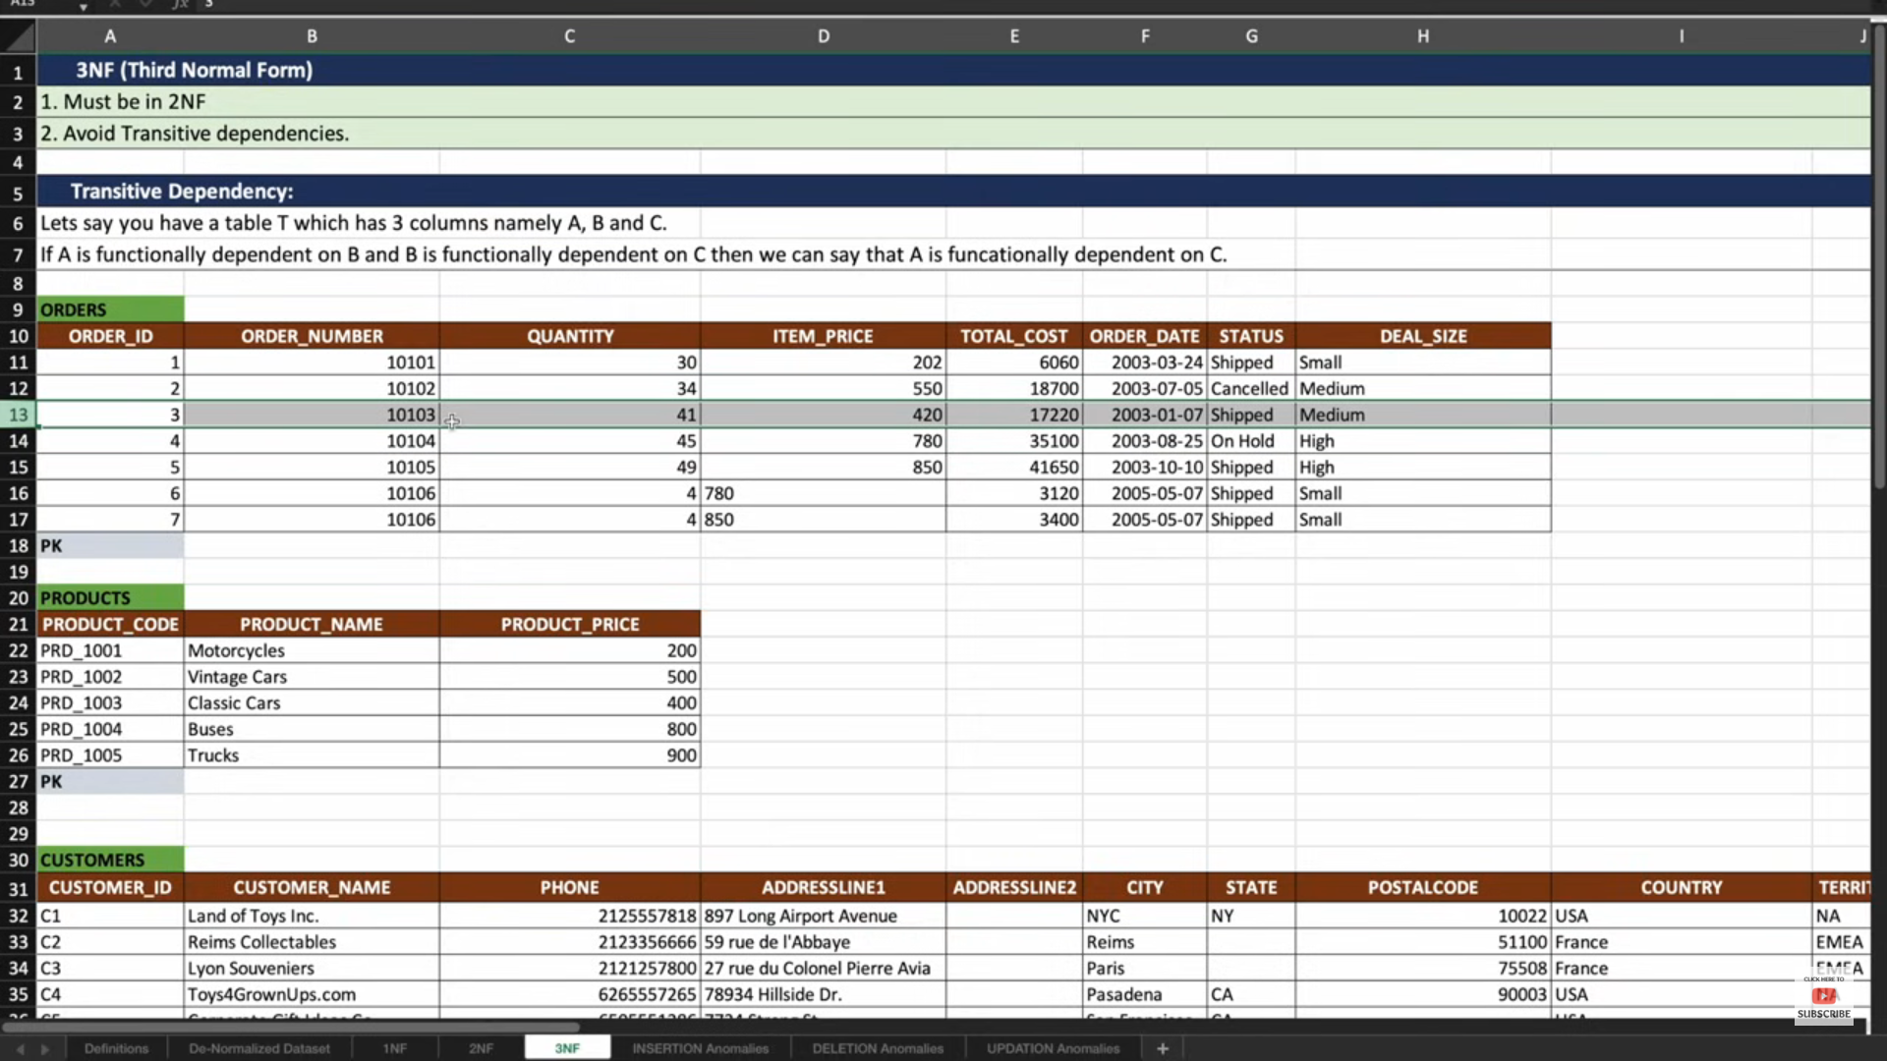

**Update Anomalies :-if we want to update product_price of one particular product we need to update many records in denormalized table**

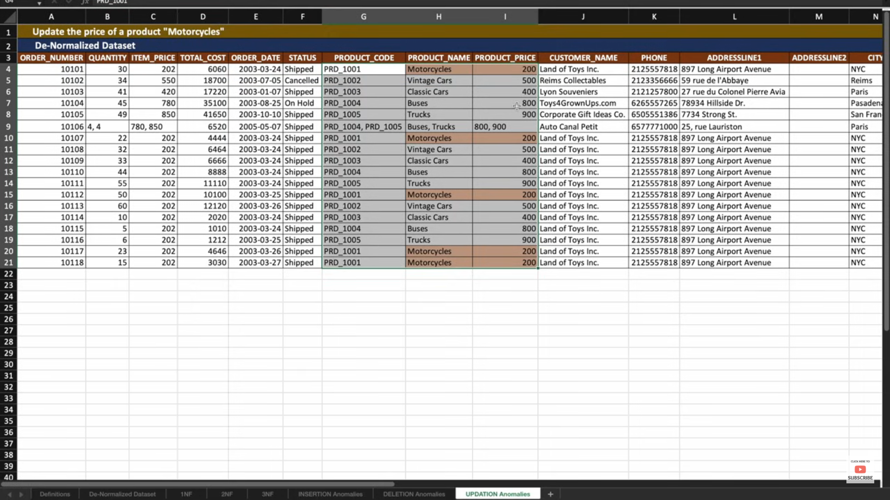

**Suppose we need to update Motor Cycle price 500 to 200.then we need to update all motorcycles records data.**

**Normalized Table :- for Normalized table just we need update data product table for that particular product.**

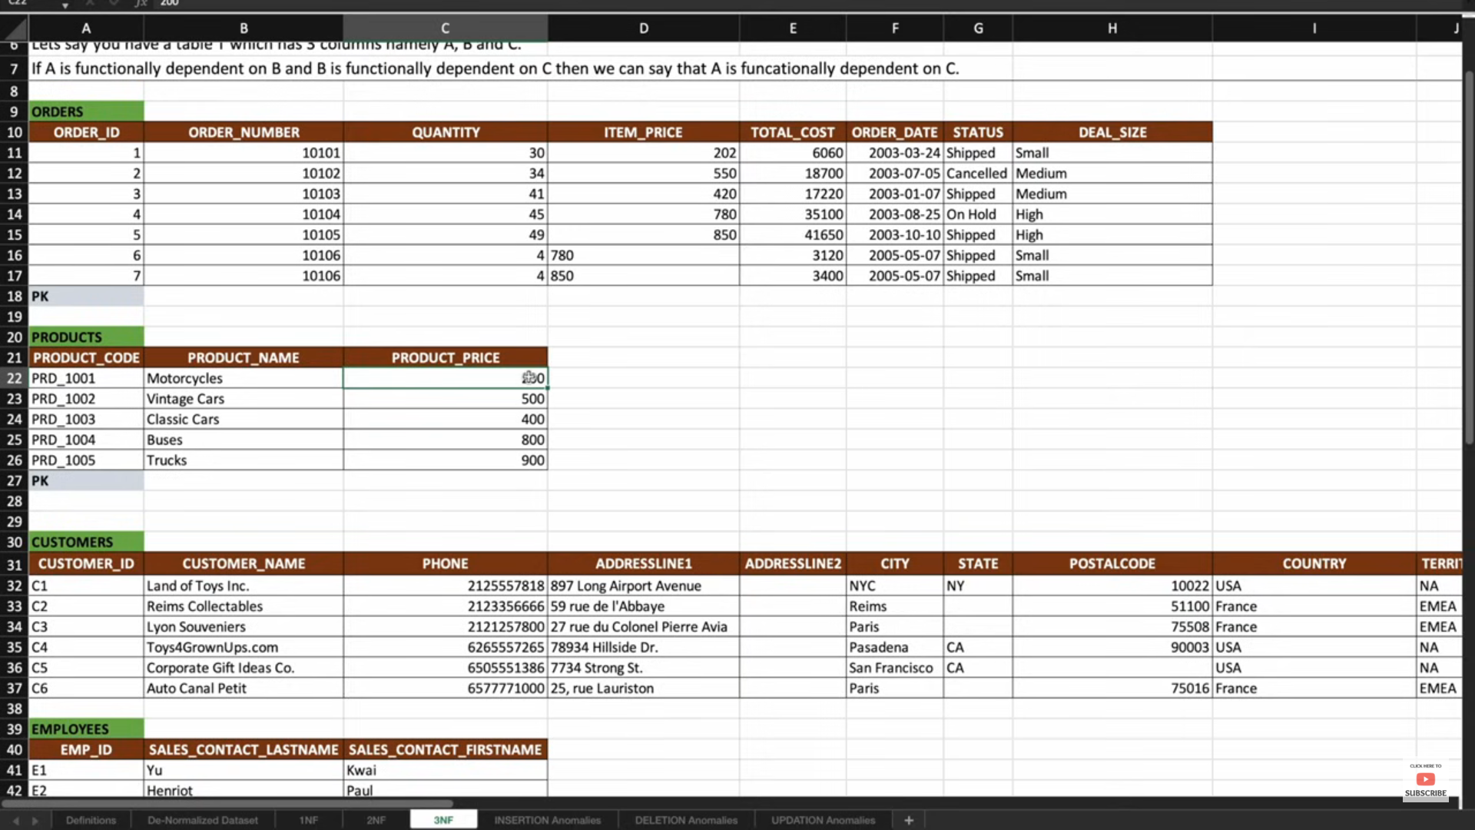

**To get the details of employees whose salary is more than their manager's salary**

SELECT e.id, e.name, e.salary, e.manager_id

FROM employees e

JOIN employees m ON e.manager_id = m.id

WHERE e.salary > m.salary;

**To get the details of employees and their manager's name :-**

SELECT e.employee_id, e.employee_name, m.manager_name

FROM employees e JOIN employees m ON e.manager_id = m.employee_id;

**Write an anonymous block which will collect the data from cursor ?**

DECLARE

CURSOR C1 IS SELECT ENAME, SAL FROM EMP;

TYPE E_TYPE is RECORD (

ename EMP.ENAME%TYPE,

sal emp.sal%type);

type emp_array is table of E_TYPE;

e emp_array;

begin

open c1;

loop

fetch c1 bulk collect into e limit 100;

for I in e.first..e.last loop

dbms_output.put_line(‘Ename’||’ ‘|| e(i).ename||’,’||’sal’||’ ‘||e.sal);

end loop;

exit when c1%notfound;

end loop;

close c1;

end;

**Package Example :-**

CREATE OR REPLACE PACKAGE emp_pkg AS

-- Public procedures

PROCEDURE hire_employee(p_emp_id NUMBER, p_emp_name VARCHAR2, p_emp_salary NUMBER);

PROCEDURE fire_employee(p_emp_id NUMBER);

FUNCTION get_employee_salary(p_emp_id NUMBER) RETURN NUMBER;

END emp_pkg;

CREATE OR REPLACE PACKAGE BODY emp_pkg AS

-- Implementation of hire_employee procedure

PROCEDURE hire_employee(p_emp_id NUMBER, p_emp_name VARCHAR2, p_emp_salary NUMBER) IS

BEGIN

INSERT INTO employees (emp_id, emp_name, emp_salary)

VALUES (p_emp_id, p_emp_name, p_emp_salary);

DBMS_OUTPUT.PUT_LINE('Employee hired: ' || p_emp_name);

END hire_employee;

-- Implementation of fire_employee procedure

PROCEDURE fire_employee(p_emp_id NUMBER) IS

BEGIN

DELETE FROM employees WHERE emp_id = p_emp_id;

DBMS_OUTPUT.PUT_LINE('Employee fired with ID: ' || p_emp_id);

END fire_employee;

-- Implementation of get_employee_salary function

FUNCTION get_employee_salary(p_emp_id NUMBER) RETURN NUMBER IS

v_salary NUMBER;

BEGIN

SELECT emp_salary INTO v_salary FROM employees WHERE emp_id = p_emp_id;

RETURN v_salary;

END get_employee_salary;

END emp_pkg;

BEGIN

emp_pkg.hire_employee(101, 'John Doe', 50000);

END;

/

BEGIN

emp_pkg.fire_employee(101);

END;

**Trigger Example**

CREATE OR REPLACE TRIGGER trg_audit_employees

AFTER INSERT OR UPDATE OR DELETE ON employees

FOR EACH ROW

DECLARE

PRAGMA AUTONOMOUS_TRANSACTION;

BEGIN

-- Insert the audit record

INSERT INTO audit_employees (audit_id, emp_id, action, action_date)

VALUES (audit_seq.NEXTVAL, :OLD.emp_id, CASE

WHEN INSERTING THEN 'INSERT'

WHEN UPDATING THEN 'UPDATE'

WHEN DELETING THEN 'DELETE'

END, SYSDATE);

-- Commit the autonomous transaction

COMMIT;

END trg_audit_employees;

END;

/

DECLARE

v_salary NUMBER;

BEGIN

v_salary := emp_pkg.get_employee_salary(101);

DBMS_OUTPUT.PUT_LINE('Salary of employee 101 is: ' || v_salary);

END;

/

**Global Temp Tables**

CREATE GLOBAL TEMPORARY TABLE temp_employees (

employee_id NUMBER,

employee_name VARCHAR2(100),

department_id NUMBER

) ON COMMIT PRESERVE ROWS;

The **ON COMMIT PRESERVE ROWS** clause specifies that the rows in the temporary table will be preserved until the end of the session. Alternatively, you can use **ON COMMIT DELETE ROWS** to delete rows after each commit.

**How do you do the diagnosis during the blocker in oracle**

SELECT a.SID "Blocking Session", b.SID "Blocked Session"

FROM v$lock a, v$lock b

WHERE a.SID != b.SID

AND a.ID1 = b.ID1

AND a.ID2 = b.ID2

AND b.request > 0

AND a.block = 1;

SELECT a.SID "Blocking Session", b.SID "Blocked Session"

FROM v$lock a, v$lock b

WHERE a.SID != b.SID

AND a.ID1 = b.ID1

AND a.ID2 = b.ID2

AND b.request > 0

AND a.block = 1;

SELECT blocking_session "BLOCKING_SESSION", sid "BLOCKED_SESSION", serial# "BLOCKED_SERIAL#", seconds_in_wait/60 "WAIT_TIME(MINUTES)"

FROM v$session

WHERE blocking_session IS NOT NULL

ORDER BY blocking_session;

SELECT ses.SID, ses.SERIAL# SER#, ses.PROCESS OS_ID, ses.STATUS, sql.SQL_FULLTEXT

FROM v$session ses, v$sql sql, v$process prc

WHERE ses.SQL_ID = sql.SQL_ID

AND ses.SQL_HASH_VALUE = sql.HASH_VALUE

AND ses.PADDR = prc.ADDR

AND ses.SID = &Enter_blocked_session_SID;

SELECT session_id "Sid", object_name "Table|Locked", oracle_username "Oracle|Username", os_user_name "OS|Username", process "Client|Process|ID", owner "Table|Owner", mode_held

FROM v$session lo, v$lock lk, v$session s

WHERE lo.session_id = s.sid

AND lo.oracle_username = s.oracle_username

AND lo.os_user_name = s.os_user_name

AND lo.process = s.process

AND lo.paddr = lk.paddr;

**Resolving the Blocker:**

Once you've identified the blocking session and the reason behind it, you can take appropriate action to resolve the issue. This might involve:

* **Committing or Rolling Back the Blocking Transaction**: If the blocking session has an uncommitted transaction, ask the user to commit or roll back the transaction.
* **Killing the Blocking Session**: As a last resort, you can kill the blocking session if it's safe to do so. Use the ALTER SYSTEM KILL SESSION command to terminate the session.

**Explain Plan and Execution Plan**

EXPLAIN PLAN FOR

SELECT employee_name, salary

FROM employees

WHERE department_id = 10;

SELECT * FROM TABLE(DBMS_XPLAN.DISPLAY);

• **EXPLAIN PLAN FOR**: This statement prepares an execution plan for the given SQL query and stores it in the PLAN_TABLE.

• **DBMS_XPLAN.DISPLAY**: This function retrieves and formats the execution plan from the PLAN_TABLE.